**CRUD Assignment Screen Shot Using Postman:**

* **Signup id 1:**

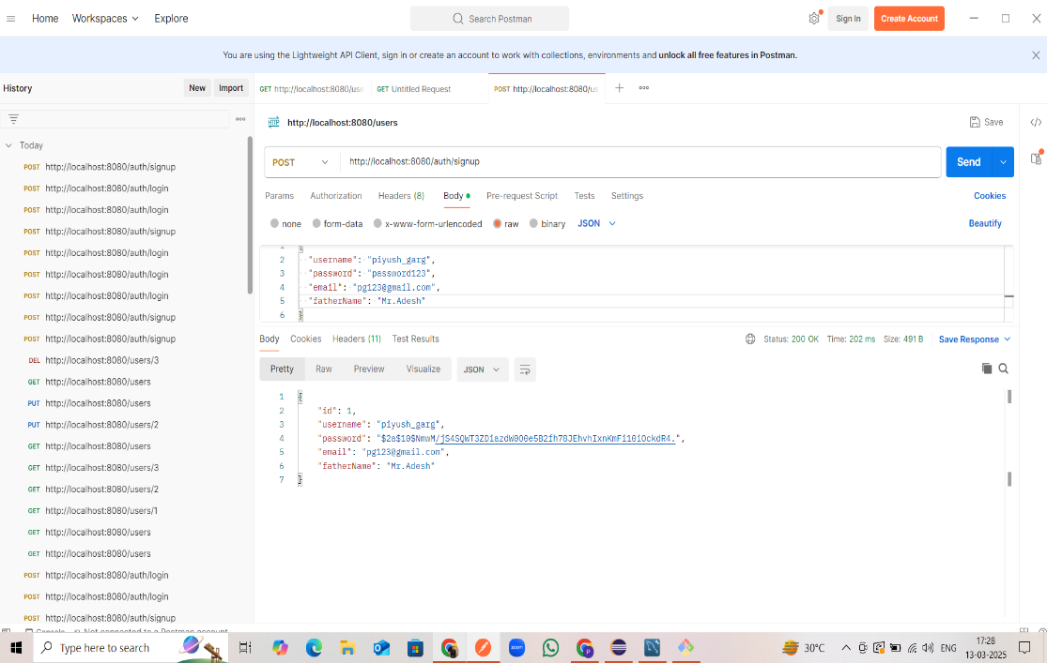

* **Login id 1:**

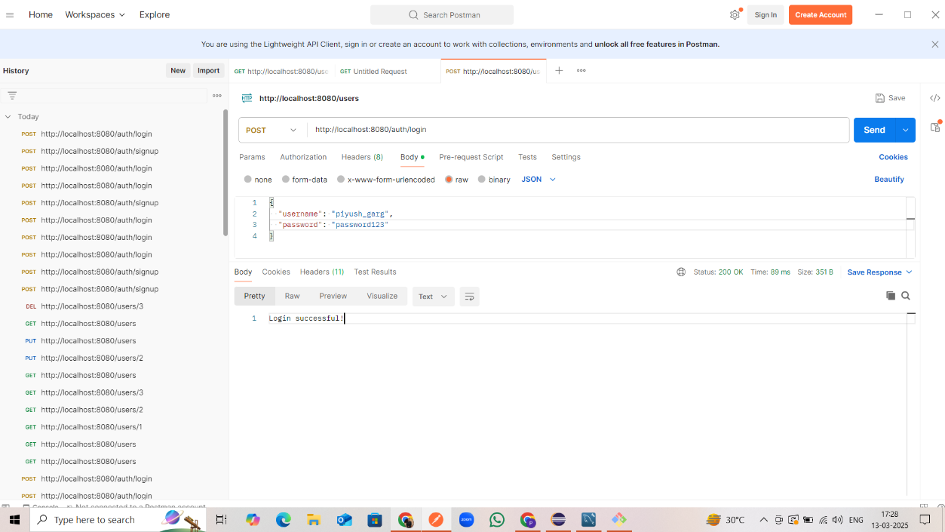

* **Signup id 2:**

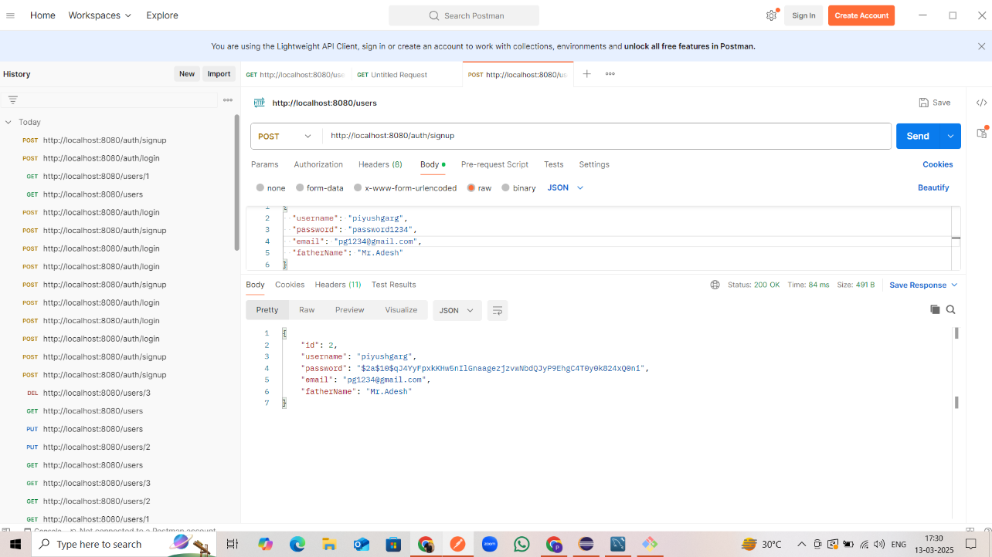

* **Login id 2:**

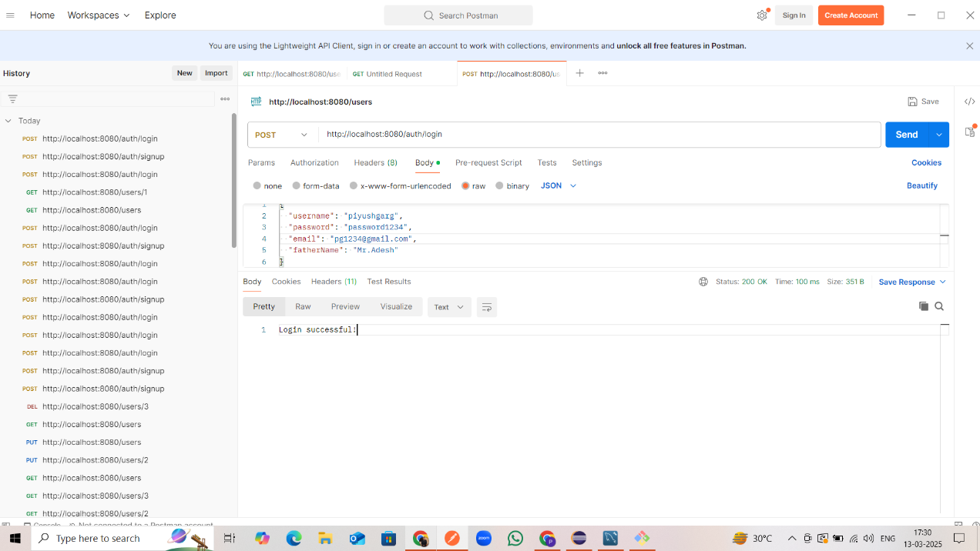

* **Signup id 3:**

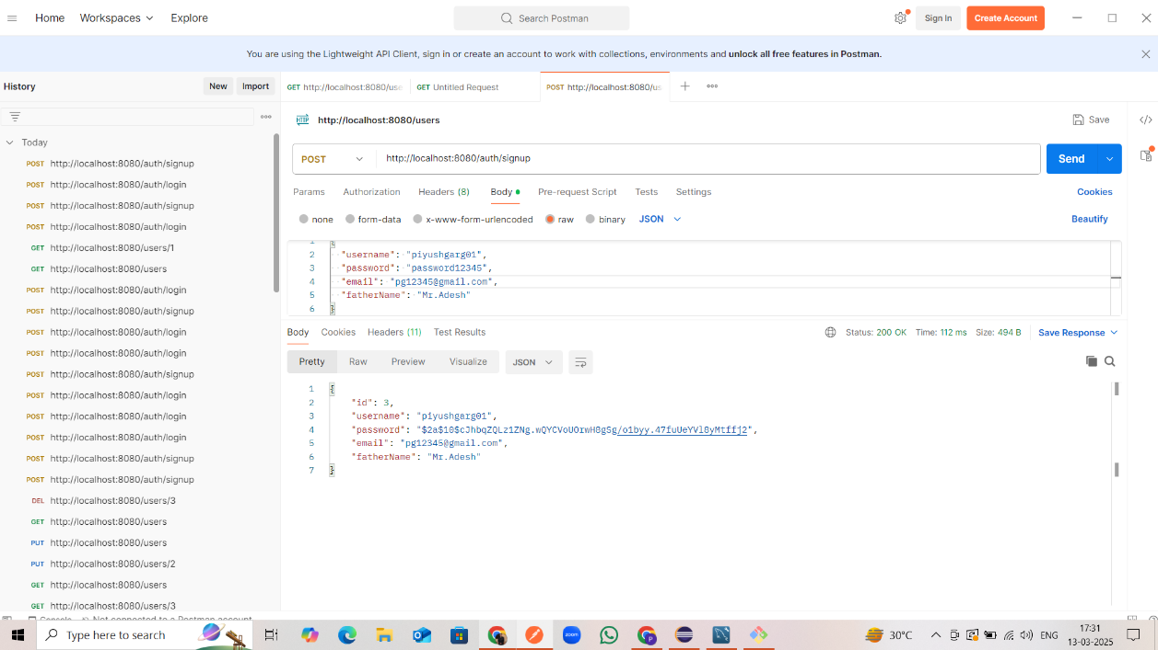

* **Login id 3:**

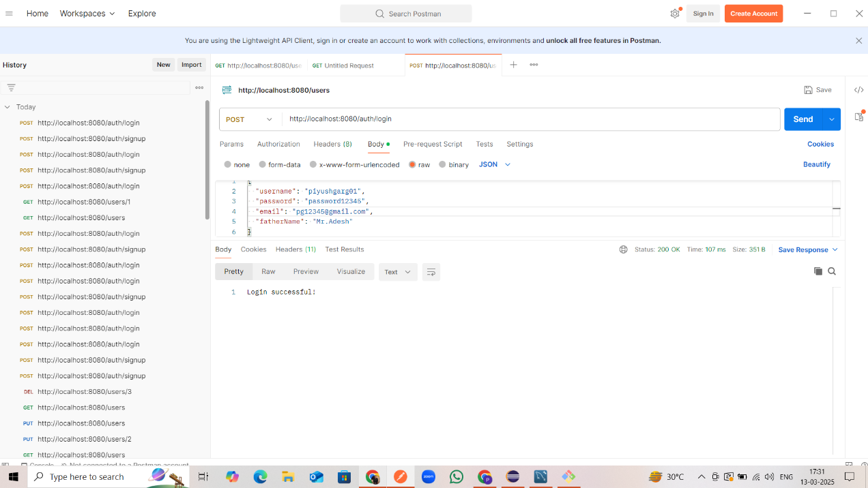

* **Get All Users:**

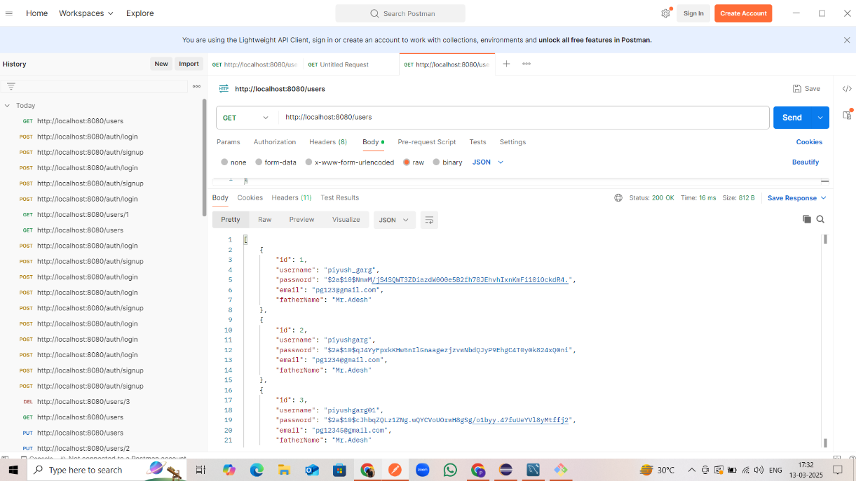

* **Get Single User id 1:**

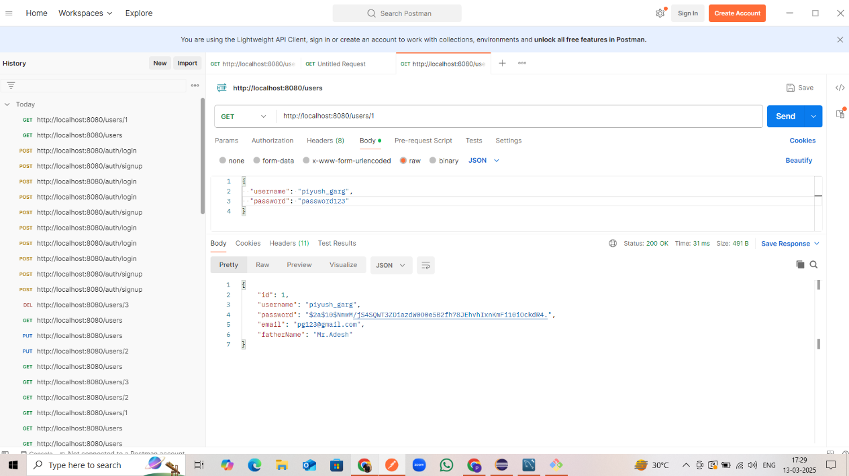

* **Get Single User id 2:**

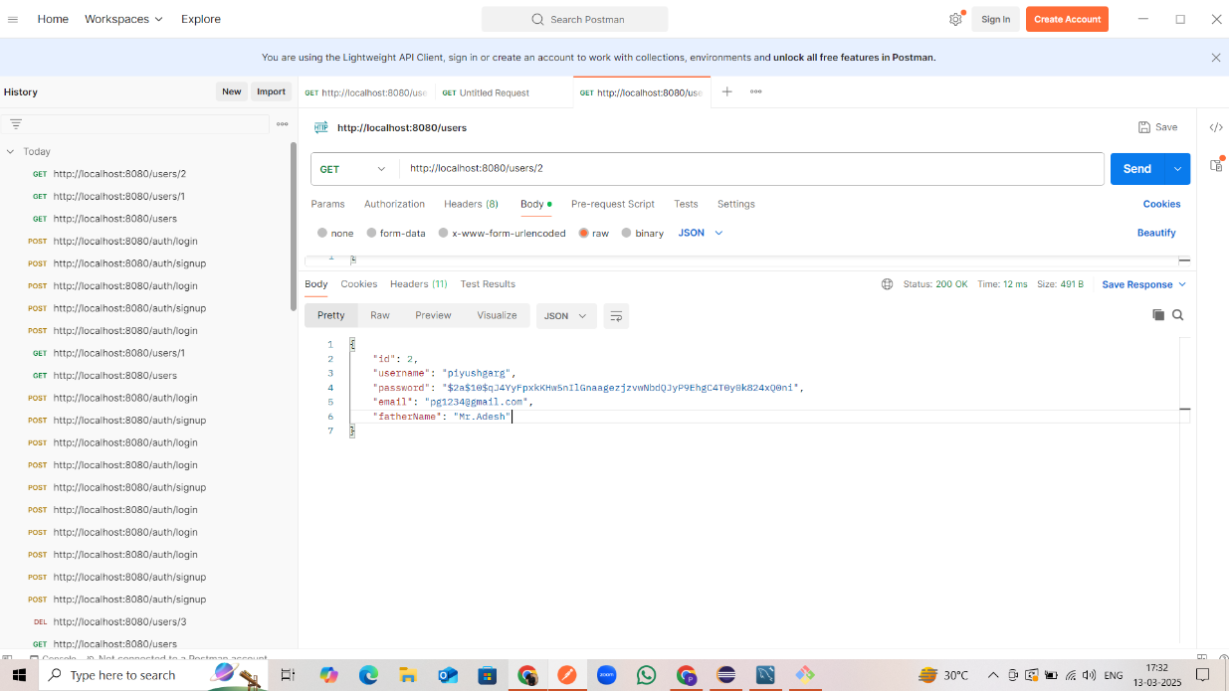

* **Get Single User id 3:**

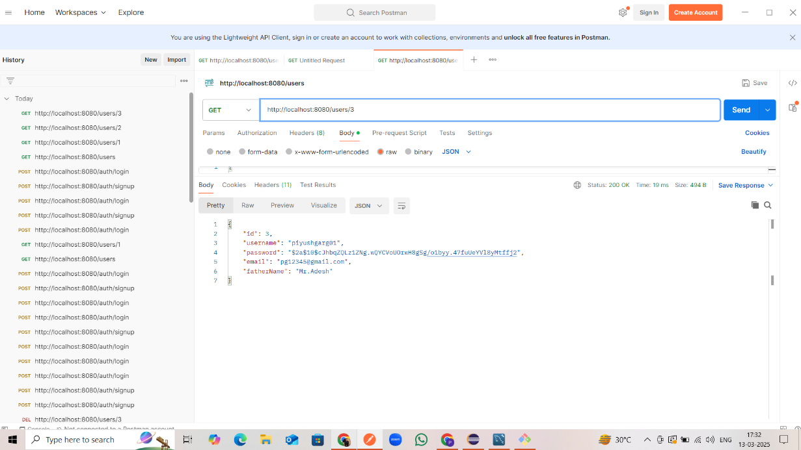

* **Update User id 3:**

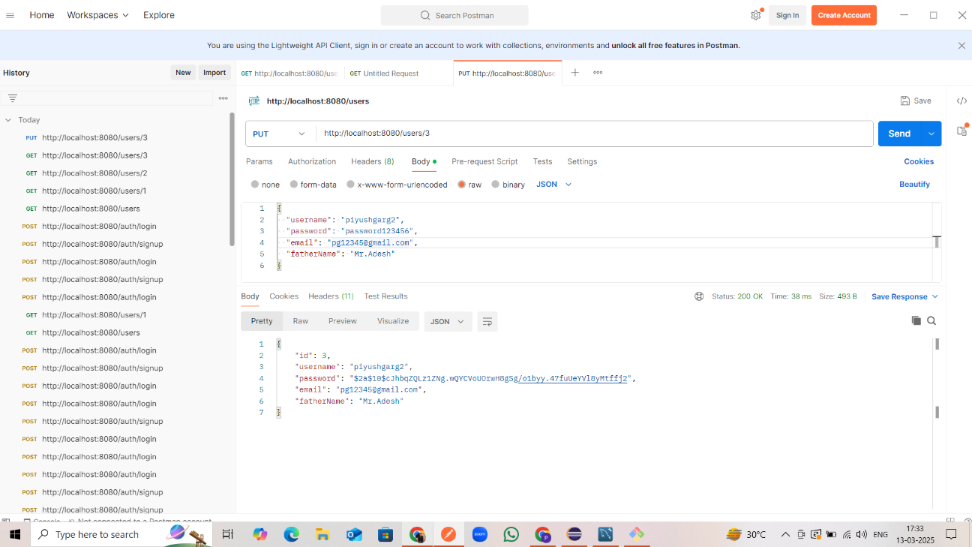

* **Update All User:**

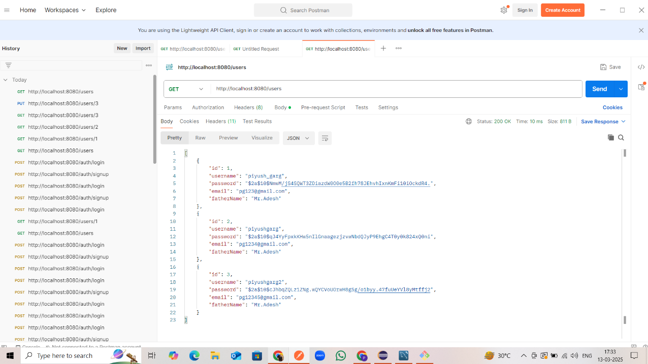

* **Delete User id 3:**

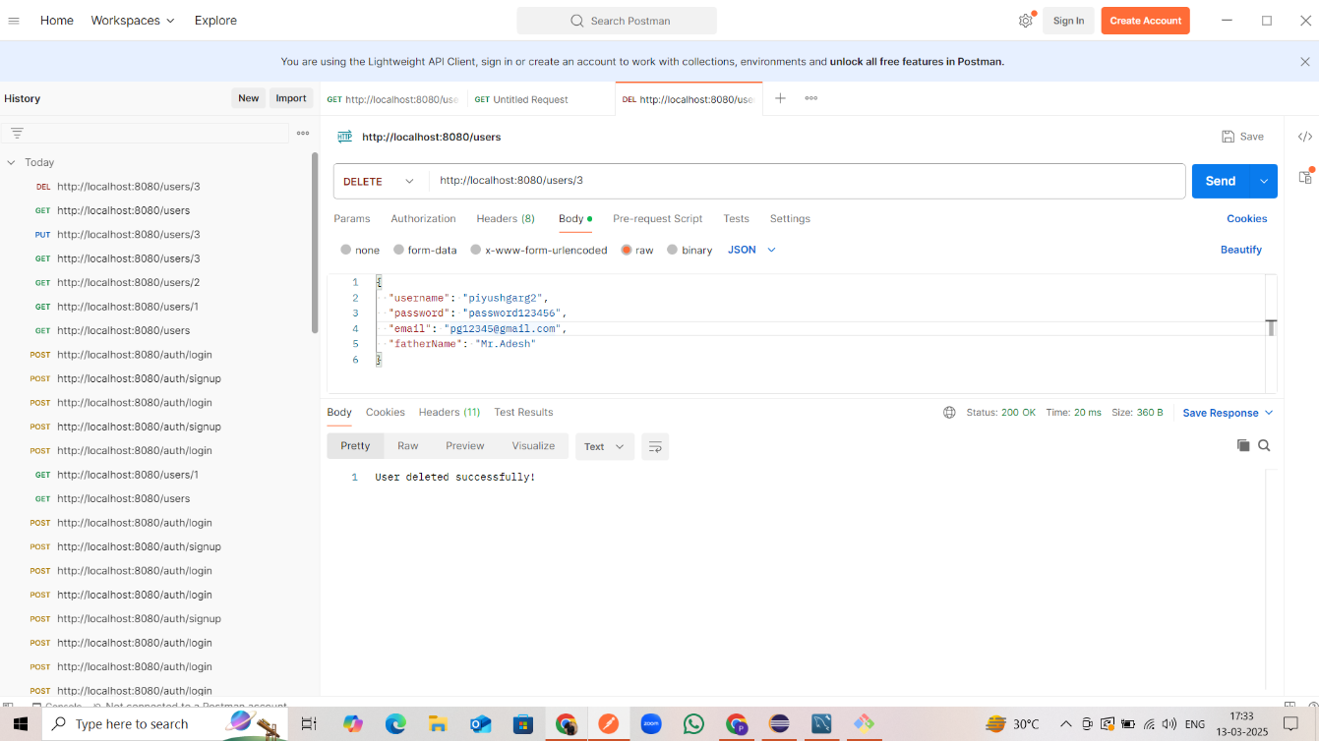

* **After Delete user id 3 showing All user list:**

